**CP Club 365 Days Challenge**

**Programming language – C++**

**Problem Statement**

<https://leetcode.com/problems/koko-eating-bananas/>

Git :- <https://github.com/Vedantbharad2603/CP_club_365_Days>

**Your Code**:

class Solution {

public:

     int minEatingSpeed(vector<int>& piles, int h) {

        int left = 1;

        int right = *max_element(piles.begin(), piles.end());

        while (left < right) {

            int mid = left + (right - left) / 2;

            if (myfun(piles, h, mid)) {

                right = mid;

            } else {

                left = mid + 1;

            }

        }

        return left;

    }

    bool myfun(vector<int>& piles, int h, int speed) {

        int hour = 0;

        for (int p : piles) {

            hour += ceil((double)p / speed);

        }

        return hour <= h;

    }

};

**Output (Screen Shot)**:

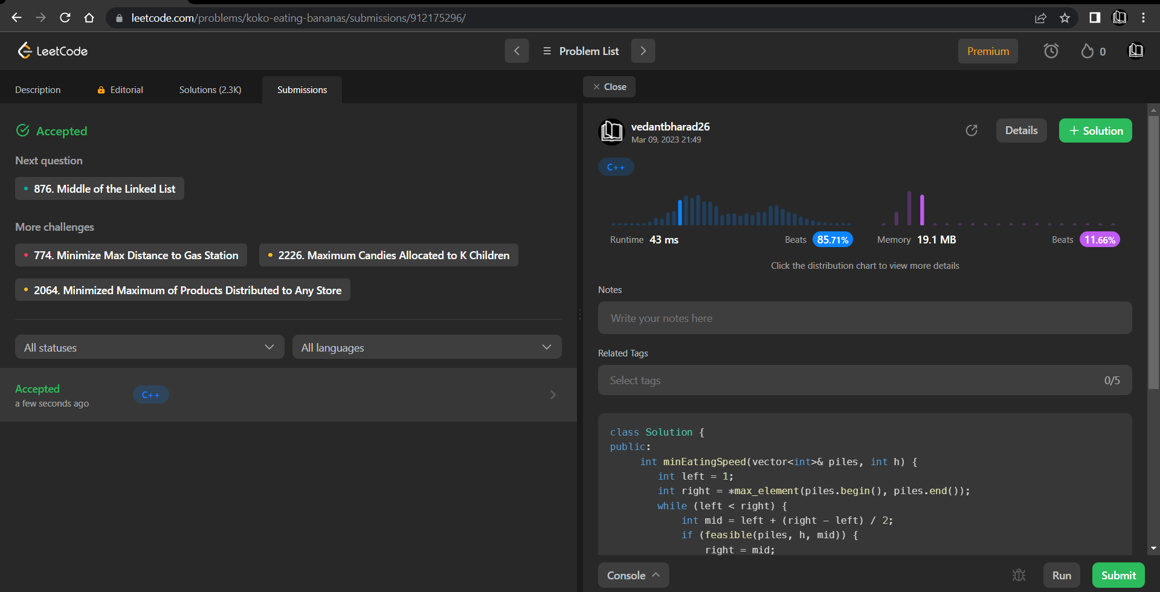

**Understanding about problem:**

-> In this task I need to return a number which is the minimum integer k which is bananas-per-hour eating speed.

Note: If you can't understand the problem, feel free to contact us and we'll help you. Please don't copy and paste from anywhere.

ALL THE BEST

Team CP Club